

Driver Education Program Evaluation

Document Information
Document Title: | Driver Education Program Evaluation
Author(s): | Jamie Gellner
Team: | Strategic Planning, Accountability, and Program Evaluation

Document Revision History

Version | Date | Changed By | Items Changed Since Previous Version
1.0 | 7/2/2018 | Jamie Gellner | First Draft
2.0 | 9/24/18 | Jamie Gellner | Second Draft w/ Addition of Survey Results

Contents
Program Evaluation Design and Logic Model 3
Background 6
Participation Data 9
Crash Data 13
Additional Information about the Behind-the-Wheel Instruction 16
Staff Interviews 21
Student and Parent Survey Results 24
Conclusions and Recommendations 27
References 28
Complete Survey Comments for Parent Survey 29

Program Evaluation Design and Logic Model

Situation: Driver education programs in Virginia schools focus on safe driving attitudes, skill development and appropriate responses to hazards. The commonwealth’s standards for driver education require extended supervised practice with a licensed parent or guardian to develop precision in the application of skills and processes to manage risks. The Driver Education Program in Albemarle County Public Schools consists of the in-class training portion, the parent seminar portion, and the in-car training portion. Other components necessary to complete the Virginia program include the 45-hour parent monitoring and the juvenile licensing ceremony.

Mission: The purpose of Drivers Education is to provide students with the knowledge, skills, and abilities necessary for vehicle safety.

Major Logic Model Components for Evaluation Design:
Inputs | Activities | Outputs | Goals
Teachers  10th grade students  VDOE curriculum | In class Driver Education Component (36 hours during Health II)  Alcohol and drugs, Aggressive driving, Motorcycle awareness, Organ donation, Distracted driving, Fuel efficiency, What to do when stopped by police officer  May also be provided virtually or in the summer at a cost | In class instruction of VDOE curriculum  Ability to obtain a learner’s permit, a learner’s permit  36 hours completed  Passing Class/Health Class | Student knowledge of fundamentals of driving and safe driving behaviors and attitudes  Students prepared for DMV Learner’s Permit Examination  Students demonstrate a working knowledge of the laws governing the operation of a motor vehicle; identify and analyze the physical and psychological conditions that affect driver performance
Instructor  Parents  Location  Policy IGAJ  State Farm Partner | Parent Seminar (90 minutes)  Offered once a month 6-730pm | Provide information to parents including crash statistics, coaching the teen driver, factors contributing to teen crashes, licensure requirements, purchasing a vehicle, insuring the teen driver, and parent responsibilities | Inform parents about their responsibilities in the driver education program  Provide lesson plans and support for state-required 45 hour parent supervised driving
Range at AHS, WAHS  Driving course at MOHS  Vehicles  Tuition ($300)  Teachers  Students with permits  Curriculum  Registration form and parent permission form  Routes  Time | Behind-the-Wheel Component of Instruction (7 hours driving, and 7 hours observation)  Offered before school, after school, summer time  Study hall hours at AHS and MOHS  Some weekends at MOHS, WAHS | Carefully structured, hands-on laboratory training  Effective lessons, planned strategically to move from abstract concepts to real-world driving experiences  Passing the road skills test  Licensure | Use visual search skills to make risk-reducing decisions by adjusting speed and/or position; demonstrate balanced vehicle movement through precise and timely steering, braking, and accelerating under a variety of conditions; and display responsible driving behaviors when alone and with peers  Meet state requirement for licensure  Issuance of Temporary (180 day) Driver’s License
Students  Parents or other adult  Vehicle  Time  Guide for Parents provided by Driver’s Ed | 45 Parent Hours Completed | Guided practice from parents  Log that records driving time (30 hours daylight and 15 hours of night) | Students become competent users of transportation system,  apply knowledge, processes, and skills to become safe, competent users of the highway transportation system  Meet state requirement for licensure
Students | Hold permit for 9 months | Ability to receive permanent license
Student  Judge | Juvenile licensing ceremony | Ceremony | Positive interaction between judge and student  Emphasizes responsibility of license  Issuance of permanent license

Evaluation Purpose: The purpose of this evaluation is to examine the ACPS Driver Education Program with an equity lens. The primary design will be a needs assessment to identify if there are any gaps between the current and the desired state. Specifically, the cabinet wishes to know:
- Is the behind the wheel program filling an otherwise unmet need for our students in an equitable manner?

- What are the strengths and opportunities of the ACPS Driver Education program?

Potential findings include participation data of students in the in-class portion and the behind-the-wheel portion, parent participation in parent seminars, analysis of staff and teacher interviews, crash data for ACPS high schools versus state and local data, and best practices for Driver Education programs as defined by VDOE. Based on these findings, we may wish to conduct a follow up survey with parents and students in the fall of 2018. Update: A survey was conducted in September, 2018. The survey was given to sophomores, juniors, seniors, and their parents and the intent of the survey was to validate reasons for participating or not participating in Driver Education and to gain additional feedback about the program.

Logic Model Components |  | Evaluation Questions | Indicators | Targets | Data Source | Limitations
Inputs: Student Stakeholders for classroom portion and in-car portion  Parents for parent seminar | Is the program serving the intended audience?  Who does participate in the various components of the program?  Is there a gap between the intended and actual population served?  Is there a waitlist for any component? |  | # of students taking the Classroom portion, demographics  # of parents attending the parent seminar and demographics  #of students attending the behind the wheel portion of drivers education, grade-level, demographics, and passing status  # of students eligible in school division, and demographics | Student Data will show if there are any gaps in participation (# of students versus # of eligible students, % demographics in classroom versus % demographics in tenth graders)  Student data for behind-the-wheel will show how many and which students choose ACPS for in-car instruction | Powerschool for classroom data of students who take classroom as Part of Health II  Parent lists kept by department versus Powerschool data  Behind the Wheel participation as reported by the Department with passing status, demographics and grade information from Powerschool | This data will not correlate because components are taken over several years  Classroom will not include Virtual Class takers or summer class takers  Department will tally Behind-the-Wheel participation using issued licenses  Department will provide parent participants based on sign-in sheets  The number of students taking classroom will not correlate with the number of students taking behind the wheel, as a permit is required before behind the wheel is taken, and the DMV requirements for a permit are outside the purview of the Driver Ed program, i.e., proof of citizenship, birth certificate, proof of residency, passage of written and eye tests, payment of fee.
Activity: Behind-the-Wheel Component of Instruction | What are best practices for delivering behind-the-wheel instruction?  What are the student outcomes for students at MOHS versus students at AHS or WAHS?  How do our student outcomes compare to state outcomes? |  | List of Best Practices versus ACPS Practices and types of behind-the-wheel instruction available  # of students participating at each High School and demographics, # of students passing the behind-the-wheel portion from ACPS instructors  # of students reported in crash one year after completing the program at each high school versus state crash data by program type | Qualitative data will show which practices ACPS uses and which ones ACPS does not use  Data will show if there are differing outcomes at each high school or consistent outcomes (passing data and crash data) Also, a target would be for ACPS numbers to be lower than state crash numbers | Interview at least two VDOE professionals in Driver Education (Best practices)  Powerschool data and data from Driver Education Program about participation  Crash data reported to VDOE  Research showing data about best practices for behind-the-wheel instruction | Outcomes will not be correlated to range component, but we can see if there are different outcomes at each of the high schools  Traffic patterns and driving habits of students at each school are reflected in crash data and cannot be controlled for when comparing data between schools
Teacher and staff stakeholders | What are special/unique features of the program in Albemarle County Public Schools?  What are opportunities and strengths of the Driver Education program in ACPS? (For teachers, students, parents, community?)  What would you change about the Driver Education Program to make it more accessible for all students? |  | List of strengths and opportunities for students, families, teachers, and the community | Interview all teachers who teach at all three base high schools in ACPS, some former staff, a police officer, and other ACPS staff like the Director | Interview Driver’s Ed Teachers including a question about teaching at each high school (differences and similarities)  Interview Program Head about advantages and disadvantages  Ask VDOE as part of interview  National research about best practices | Not getting all of the stakeholder input due to the time of the year—leaving parents and students out of survey/interview

Background

Motor vehicle crashes are the leading cause of death for children, teenagers, and young adults in the United States (Subramanian, 2012). It is widely accepted that teenagers, specifically, drivers who are ages 16-19, contribute a disproportionate number of crashes to the US total compared to the percentage of drivers who make up this group. In Virginia, the number of total crashes and the number of total licensed drivers has increased from 2013-2017 and is reflected in the most recent report by the Virginia Department of Motor Vehicles Highway Safety Office. In Albemarle County, drivers aged 16 to 19 are much more likely to be involved in crashes. (The fatality reflected in the following table in 2016 is a Powhatan teen who was driving in Albemarle. Inexperience and speed were cited as the main crash factors.) For this reason, many states purport that the aim of Driver Education is to produce safe drivers.

Virginia Crash Report for Albemarle County from 1/1/ 2015 to 6/30/ 2018 provided by the Department of Motor Vehicles (The 2018 data contained in this report is preliminary and subject to change. Some crash information may not have been reported or finalized by Law Enforcement.)

Age Group | 2015 |  |  | 2016 |  |  | 2017 |  |  | 2018
Age Group | People involved in crashes | Fatalities | Injuries | People involved in crashes | Fatalities | Injuries | People involved in crashes | Fatalities | Injuries | People involved in crashes | Fatalities | Injuries
Unknown | 15 | 0 | 1 | 9 | 0 | 0 | 13 | 0 | 2 | 6 | 0 | 0
Under 8 | 1 | 0 | 1 | 0 | 0 | 0 | 2 | 0 | 4 | 0 | 0 | 0
8 to 9 | 1 | 0 | 1 | 1 | 0 | 1 | 0 | 0 | 0 | 0 | 0 | 0
10 to 14 | 4 | 0 | 5 | 5 | 0 | 5 | 2 | 0 | 2 | 2 | 0 | 2
15 | 5 | 0 | 3 | 4 | 0 | 4 | 4 | 0 | 3 | 2 | 0 | 1
16 | 45 | 0 | 14 | 50 | 1 | 7 | 46 | 0 | 9 | 15 | 0 | 0
17 | 98 | 0 | 32 | 76 | 0 | 14 | 92 | 0 | 25 | 38 | 0 | 10
18 | 87 | 0 | 19 | 84 | 0 | 16 | 101 | 0 | 26 | 54 | 0 | 13
19 | 113 | 0 | 25 | 98 | 0 | 25 | 92 | 0 | 28 | 30 | 0 | 14
20 | 8 | 0 | 3 | 10 | 0 | 5 | 4 | 0 | 1 | 1 | 0 | 0
21 to 25 | 22 | 0 | 4 | 31 | 0 | 12 | 29 | 0 | 6 | 17 | 0 | 6
26 to 30 | 25 | 0 | 11 | 35 | 0 | 8 | 27 | 1 | 9 | 16 | 0 | 2
31 to 35 | 18 | 0 | 3 | 29 | 0 | 10 | 25 | 0 | 9 | 6 | 0 | 1
36 to 40 | 23 | 0 | 5 | 20 | 0 | 5 | 22 | 0 | 8 | 8 | 0 | 4
41 to 45 | 25 | 0 | 3 | 14 | 0 | 5 | 15 | 0 | 2 | 5 | 0 | 3
46 to 50 | 20 | 0 | 8 | 15 | 0 | 5 | 32 | 0 | 2 | 9 | 0 | 3
51 to 55 | 26 | 0 | 2 | 25 | 0 | 5 | 24 | 0 | 7 | 14 | 0 | 3
56 to 60 | 24 | 0 | 6 | 16 | 0 | 4 | 24 | 0 | 4 | 5 | 0 | 0
61 to 65 | 15 | 0 | 0 | 12 | 0 | 2 | 13 | 0 | 4 | 10 | 0 | 3
66 to 70 | 7 | 0 | 1 | 14 | 0 | 1 | 19 | 0 | 5 | 3 | 0 | 0
Over 70 | 17 | 0 | 6 | 14 | 0 | 5 | 11 | 0 | 1 | 8 | 0 | 1
Totals | 599 | 0 | 153 | 562 | 1 | 139 | 597 | 1 | 157 | 249 | 0 | 66

In the 1990s and early 2000s, formal evaluations of U.S. high school driver education programs indicated little or no reduction in crashes per licensed driver (Mayhew, Simpson, Williams, & Ferguson, 1998; Vernick, Guohua, Ogaitis, Mackenzie, Baker, & Gielen, 1999). Other school-based programs, such as those intended to reduce alcohol-impaired driving, have not been shown to be effective, at least in the short term (Williams, 1994). There is evidence that skid control training and other kinds of advanced skill training increase crash risk, particularly among young males (Mayhew, et.al., 1998; Christie, 2001; Williams & Ferguson, 2004). Authors of the relevant studies have suggested that young drivers trained in these skills become overconfident, leading them to take unnecessary risks.
Graduated driver licensing (GDL) systems were introduced in 1996 in an attempt to improve driver education training and more fully prepare young drivers for the road. These laws reduce risk by making sure teens gradually build up driving experience under lower-risk conditions as they mature and develop skills. That means limiting nighttime driving, restricting teen passengers, and making sure teens get lots of supervised practice. Graduated licensing has reduced teen crashes 10-30 percent on average. In particular, studies have found that strong GDL programs are associated with lower fatal crash involvement rates for 16- and 17-year-olds (Zhu, Cummings, Chu, Coben, & Li, 2013).
All 50 states and the District of Columbia have a three-stage GDL system. The United States does not have a national GDL law. State lawmakers decide what provisions to adopt and how to enforce them. Research shows that states with the strongest laws see bigger reductions in teen driver deaths than states with weak laws. Virginia is not the most restrictive state, but it has strong requirements. For more details, see this link http://www.iihs.org/iihs/topics/laws/graduatedlicenseintro?topicName=teenagers.
For teens under 18 in Virginia, Driver Education is required which includes 36 hours of classroom instruction and 14 hours of in-car instruction (7 driving and 7 observation). Virginia also has a minimum entry age of 15 and 6 months and a mandatory permit holding period of 9 months, so the earliest age for licensure is 16 and 3 months. Teens must have 45 hours of supervised driving and 15 must be at night. Unsupervised driving is prohibited for teens from 12-4am. In Northern Virginia and in Albemarle, a parent seminar is required. When teens earn a restricted license, they may have no more than one passenger under the age of 21 in the first 12 months after licensure. If you are 18 or older, you do not have to complete Driver Education and you may obtain a permit and hold it for 60 days before moving on to your licensure exam.
Besides implementing graduated driver licensing systems, another major recommendation from the research is to change how instruction is delivered so that it is more engaging for students and to focus on changing attitudes about safe driving and not just correcting behaviors. The VDOE curriculum is potentially leading the nation in this change with their 2015 revamp of the curriculum. VDOE says that the stated goal is to “create a culture of safe driving behaviors by fundamentally improving driver behavior, not just traffic safety knowledge and skills; whereby students adopt safe driving behaviors and attitudes….” (VDOE, 2017, p.5).
There is little research addressing factors that influence obtaining a driver’s license. Some conjecture that GDL laws resulted in the downward trend for teen licensing—because of the additional requirements before the age of 18. National surveys of high school seniors show a downward trend in teen licensing (Shults & Williams, 2013). A study conducted in 2012 (Tefft, Williams, & Grabowski) concludes that there was little evidence that those who delayed licensure did so for the purpose of avoiding their state’s GDL system. However, a substantial minority of all young people, and a majority of those who are black, Hispanic, or from low-income households, begin driving without the protection that GDL systems are designed to provide. In other words, fewer black, Hispanic, or low-income teens are being licensed before the age of 18. The most common self-reported reasons for delayed licensure were not having a car, being able to get around without driving, and costs associated with driving (Tefft, Williams, & Grabowski, 2012). In an online national survey conducted in 2010, 22 percent of the 18-year-old respondents had not yet obtained a learner’s permit. When they were presented with a list of possible reasons and asked to indicate which, if any, were a factor, 55 percent indicated that no car was available, 30 percent said that driving costs too much, 24 percent indicated that licensing requirements were a hassle, 13 percent indicated they did not need a car to connect with friends, and 6 percent said that Facebook and texting kept them in touch with friends (Williams, 2011). Students are missing out on important driver education training due to economic factors.
Recent articles highlight the fact that many states are choosing not to fund driver education in public schools and point out that data reveal that its lower income teens who are missing out on obtaining their licenses (Valeii, 2018). There is a similar pattern nationwide of teens missing driver's education because they lack financial assistance. At least one state, Georgia, offers a grant scholarship program to young drivers. It is funded by the state with the traffic citations issued. Only fees approved by the Virginia Department of Education may be charged for the laboratory (behind-the-wheel) portion of Driver Education and VDOE provides funding for schools who offer the curriculum through Basic Aid. Currently, the reimbursement amounts to about $35 per student but it has been $65-70 per student in the past. A program is self-sustaining when the tuition fees charged and the basic aid funding cover the costs of the program. The program in ACPS is self-sustaining and charges a tuition of $325. Charging a fee is optional for local school boards, and has no impact on the fee charged during the summer. Summer school fees require no prior approval from the Department of Education, and do not result in a reduction in basic aid.

In Virginia, a few school divisions no longer offer behind-the-wheel driver education and these are: Appomattox, Botetourt, Clark, Culpepper, Fauquier, Fluvanna, Goochland, Greene, Pittsylvania, Rappahannock, Roanoke County, Spotsylvania, York (go to Newport News), Alexandria, Danville, Falls Church, Portsmouth, Suffolk, Poquoson, and Manassas Park. In terms of offering reduced fees, some school divisions, like Hanover, waive the fees in whole or in part for those students who cannot afford the fees. In Albemarle County Public Schools, the classroom portion of behind-the-wheel is offered during Health and PE II. If students take this course online, then they do not receive the Driver Education portion. Most of these students then take the Virginia Association for Driver Education and Traffic Safety (VADETS) course online to complete the classroom requirement. This course is $109 and fulfills the 36-hour requirement. (http://vadriveredu.org/login/index.php) ACPS also offers Summer Classroom Driver Education training through Open Doors and the cost is $180. Additionally, limited numbers of classroom driver education courses are offered by commercial providers at a higher cost.

In summary, much research has shown that driver education training has little impact on crash rates. GDL laws, especially those that raise the minimum age for licensing, have improved crash rates and focusing on driver attitudes may improve crash rates. More recent trends in driver education indicate that economically disadvantaged teens are more likely to wait to be licensed. For those interested in a thorough literature review please see this link. https://www.sciencedirect.com/science/article/pii/S0386111211000021

Participation Data

There are several components to the Driver Education program of instruction. The first “step” is to take the 36-hour classroom component during Health and PE II. Because it is given in this class, most students take the course during their tenth grade year. In the last three years, ACPS is averaging an 88% participation rate for driver education in the tenth grade across the three large high schools. (Students from Murray High School have a similar rate of participation, averaging 89% over the last three years. These students then may attend behind-the-wheel at one of the larger high schools, usually AHS.)

The numbers on the following charts show a comparison between the students enrolled at the beginning of the school year as reported to the state versus the number of students at the end of the school year who had enrolled in the classroom portion of Driver Education through Health and PE II. The numbers may be different as students move into our out of schools or are identified (as economically disadvantaged, SPED, or EL) later in the year. There is high participation for economically disadvantaged students and for English language learners while SPED students have a lower participation rate.

Black and Hispanic students participate in the class more often than Asian, white, and multi-racial students do. The primary reason that students do not participate in Health and PE II, and therefore Driver Education, is that they take the course online instead of in the classroom. The online Health and PE II course is free during the school year and summer school rates are applied if taken in the summer. The online course does not include Driver Education. If Health and PE II is taken virtually, then the Driver Education component must be taken during the summer through Open Doors at a cost of $180, virtually through VADETS for a cost of $109, through another provider, or perhaps, it is not taken.

After the classroom portion of Driver Education, students may apply for their learner’s permit. To receive a permit, they must pass a two-part exam, eye test, pay a fee, and provide documentation required by the DMV. If they take and pass the test, they may begin the 45 hours of practice with their parent/guardian. The Virginia Department of Education provides a 52-page training log complete with guidance, training suggestions, hour’s logs, and contractual agreements. Check out the link below to see it in its entirety. http://www.doe.virginia.gov/instruction/driver_education/parent_teen_driving_guide.pdf

In Albemarle County Public Schools, parents are required to attend a 90-minute parent seminar. At the seminar, which is held once a month and rotates between the three large high schools, Ms. Waters-Wicks discusses the 45-hour training requirements, teen crash data, insuring teenage drivers and other parent and student responsibilities as it relates to driver safety. Parents from local private schools and home-school parents also attend these seminars as evidenced by the sign-in sheets.

Ms. Karen Waters-Wicks, community program coordinator and the program head for Driver Education, does collect the sign in sheets for these meetings; however, the data is not usable at this time. After gathering all of the lists, a spreadsheet resulted with the parent names and students names. Many students are no longer in PowerSchool (either because they graduated or they moved) and many students are still in elementary or middle school. Once a parent attends one seminar, he or she does not have to attend again for other students. Since parents can register through the “Open Doors” application, it may be beneficial to track this information electronically using that system or PowerSchool.

Students may not begin the behind-the-wheel portion of Driver Education without having a parent/guardian attend a parent seminar. All students who have enrolled in behind-the-wheel at Albemarle High School, Monticello High School, or Western Albemarle High School have completed or started the classroom portion in some way, have earned their learner’s permit, have begun the 45-hour training requirement, have had a parent attend the parent seminar, and have paid the tuition fee (or at least a deposit). Because of the graduated licensing requirements, and for the reasons mentioned in the introductory research, students enroll in behind-the-wheel when it is convenient for them to do so. This may be in the sophomore, junior, or senior year. For many, it is after they turn 18 and after they graduate high school. Because of busy schedules, many students take behind-the-wheel from private companies. This evaluation will attempt to shed some light on these numbers, but we do not have a complete picture with the available data.

In ACPS, behind-the-wheel is offered at Albemarle High School, Monticello High School, and Western Albemarle High School. The tuition is currently $300 and is payable in installments if needed. (During the summer session the tuition fee is $325.) ACPS offers before school, after school, and summer behind-the-wheel training. AHS and MOHS also allow students to train during the school day if they have a study hall (WAHS does not have an instructor available during the school day) and some instructors are able to train on the weekends. Private companies primarily train before school, after school, and on the weekends and may provide hours that are even more flexible for busy students. They also pick students up from home and from school. There are only a few private companies in our area and they are small, having 1-3 instructors listed on average for the behind-the-wheel training.

Participation Data Behind-the-Wheel at Albemarle High School as Compared to School Demographics

There are many factors that influence the participation in the behind-the-wheel portion of driver education including failure to pass the permit exam, lack of documentation, lack of interest in getting a driver’s license, and economic factors such as lack of a family vehicle or inability to pay for a teen driver on insurance. National trends show that teens from economically disadvantaged homes and black or Hispanic teens are less likely to obtain a driver’s license before the age of 18. Looking at the participation data for Albemarle High School against the demographic data of Albemarle High School, it appears that white students are over-represented and black and Hispanic students could be under-represented. It also appears that economically disadvantaged students are under-represented.

Of the 329 students represented in the past three years at Albemarle, 36 (10.9%) took advantage of paying for the range tuition through installments rather than all at once. Forty-five (14%) of these 329 students were re-tested in order to “pass” the course.

Looking at the time between in-class completion and behind-the-wheel completion, there is an average of 323 days, so most students complete the behind-the-wheel in the year following the classroom completion. The mode was 182, so several complete within 6 months and the median number was 260 days. The range spread from negative days (students can start behind-the-wheel if they have a permit and maybe have not completed classroom) to 1110 days. The day count was so high (over 755-1110) for 36 students that one can assume they completed the summer after graduating high school.
Without further investigation into the data, there is little information to say why students are not participating in the behind-the-wheel program or if they are participating elsewhere. In terms of overall participation, if we only estimate the juniors and seniors in AHS, there are approximately 1,000 students. The program is seeing about a 10% participation rate each year in the behind-the-wheel program.

If there is a goal to increase overall participation, one may begin by hiring additional staff to teach the behind-the-wheel curriculum. Since there are no waitlists for the classes, it is difficult to see the demand. The increase of commercial providers in the area (we will see in the next section) may be an indicator of the demand.

Crash Data

Vanessa Wigand and Janet Ragland from VDOE stated that Albemarle has a quality program with outstanding instructors and consistently “above average” crash statistics, meaning that ACPS has a low rate of crashes. Crash data is reported to VDOE by the DMV and collects information on the first twelve months after a driver is licensed. Therefore, the report is usually two years behind the current school year.

DRIVING SCHOOL COST & CRASH RATE COMPARISON USING MOST RECENT CRASH DATA 2015-16
SCHOOL NAME | PRICE | 2015-16 TOTAL STUDENTS | 2015-16 CRASHES | 2015-16 CRASH PERCENTAGE  RATIO
Albemarle Driving School LLC  6506 Woodbourne Lane  Crozet (1 instructor) | $275.00 | 69 | 5 | 7.25
Augusta Defensive Driving School  1025 B. W Main St  Waynesboro | $325.00 | 152 | 7 | 4.61
Charlottesville Academy of Driving  3462 Scottsville Rd  Charlottesville | No Data | 83 | 5 | 6.02
Green Light Driving School  1924 Arlington Boulevard  Charlottesville  (3 instructors) | $350.00 | 306 | 15 | 4.9
Albemarle County Schools Community & Driver Education | $300.00* | 311 | 11 | 3.5
Charlottesville High School | $175.00 | 117 | 6 | 5.13

- Commercial School State Average Crash Ratio: 5.00
- Public School State Average Crash Ratio: 4.58
- *denotes cost in this school year. The tuition is now $325.

Albemarle County Public Schools students perform well as compared to the private companies in the region. These are the commercial driving schools that report their information to the Department of Motor Vehicles and for whom data can be collected. In the most recent school year, the ACPS program crash rates were lower than Charlottesville City Schools and all other commercial driving schools in the area. The crash rate is also below the state average for all public schools in Virginia in this school year.

The next chart shows crash data for several years and breaks it out by high school. Students are recorded at AHS, MOHS, or WAHS if that is where they took the behind-the-wheel driver education—even if they are not a student in the school. These numbers include ACPS students who attend Murray, home-school students, private school students, and students from other public schools. Many of our students attend the program at AHS in the summer instead of their base high school as well.

The data show that in total, Albemarle County Public Schools consistently have a low crash rate as compared to all public high schools and all driver training schools in the state of Virginia. Specifically, in three of the last six years, Albemarle County Public Schools perform better than all public high schools in the state. In every year ACPS performs better than all Driver Training schools. One can see that in some years, Albemarle High School students have higher crash rates than the other schools and state averages.

Albemarle Driving School is a new commercial school that has begun in the past two years. There are only a few others listed on the DMV website as options for our area and their staffing is small. Green Light Driving School fairly consistently graduates 300 students while the number of students in Albemarle County appears to be going down slightly.

If there is a desire to increase participation, further investigation should be done to see if there is a real demand. Ms. Waters-Wicks did recently lose staff members and is working to replace them. It can be difficult to hire for this position as the hours vary and it can be high-stress. (The classroom teachers with whom I spoke had no desire to teach the in-car portion!)

Crash Data by School 2010-2015 (red denotes highest crash rate that year while blue highlights the lowest two)

Additional Information about the Behind-the-Wheel Instruction
The behind-the-wheel curriculum is the same at each of our high schools, but the instructional tool, the driving range, is different. At Albemarle High School, there is a multiple-car-range facility with a tower that has some storage and office space. At Monticello High School, the bus parking lot is turned into the driving range through the use of cones and signage. At Western Albemarle High School, there is a painted space behind the school that serves as the bus staging area and the driver education range. This space also has a small tower. All of these facilities are acceptable and do impact the timing and type of instruction. For example, at WAHS and MOHS, driver education cannot begin until after the school buses depart in the afternoon. And, at MOHS, additional cost is spent for instructor’s time to set up the cones that make up the driving course. Finally, teachers argue that the ranges provide various preparation for real-world driving experience—what it will be like on the “real” roads. The program guide developed by VDOE (2017) states:

Laboratory instruction may include simulation, multiple-car-range (MCR), and on-street instruction. The average length of time a student can safely operate the driver education vehicle in complex, demanding driving situations may vary. Many teachers have found that student learning is maximized by offering two 25-minute instructional “blocks” to satisfy the minimum 50-minute requirement. Switching the two student drivers more frequently is especially effective during initial lessons when students may be nervous, anxious, or afraid. In addition, dividing the lesson into two segments allows the teacher to intensify the number of steps and complexity of the performance skills. It also maximizes learning for the observing student who immediately applies the skills and processes they observed.
Instruction should begin in the school parking lot, or at the school division’s designated location, such as a multiple-car-range facility. Instruction should end at the same location unless local school board policy allows students to be dropped off at home or at another location. Teachers should coordinate with parents via text or another mode of communication when students are dropped off at home. Schools should consider installing cameras and/or GPS systems telematics in vehicles to improve safety and oversight. These systems record both the driver and the road, and provide real time monitoring of speed, location, and let administrators know when vehicles deviate from their set route.

A multiple-car range (MCR) enables the driver education teacher, from a position outside of the vehicle using electronic or oral communication to teach and supervise several students simultaneously each of whom is operating a motor vehicle at an off-street facility specifically designed for this type of instruction. Range instruction provides basic parking lot skills, such as steering, stopping and accelerating, backing, parking, turning and managing intersecting traffic in a safe environment. The range is also the preferred environment to provide students with simulated emergency and basic evasive driving experiences, such as blocked lane, ABS braking, hydroplaning, and off-road recovery. Learning experiences on the MCR should be offered in a sequence preparatory to and integrated with on-street driving and driving simulation. Whenever possible, however, students who have mastered “parking lot” skills on the range should “graduate” to actual on street learning experiences. The size, design, and number of vehicles used on the range will determine the types of experiences that may be provided. For example, the experiences provided on a 300’ x 500’ area utilizing 6-8 vehicles are greater than those provide on a standard range, which is 150’ X 300” with 4-5 vehicles. One period of instruction (driving or observing) on a multiple-car-range may be substituted for one period of on-street instruction (driving or observing). This one-to-one substitution ratio may be used for up to a maximum of four periods of on-street driving and four periods of observing.

Actual driving on roadways is a more valuable learning experience than simulated or multiple-car-range driving experiences. At a minimum, students must receive at least three periods of on-street driving and three periods of on-street observing. A minimum of two, and a maximum of three, students may be assigned in a vehicle during on-street instruction. Students may receive a maximum of two periods of classroom instruction, or two periods of laboratory instruction in a 24-hour period. Up to four periods of on-street driving and four periods of on-street observing may be replaced with any combination of simulation and multiple-car-range instruction. A period of instruction must be at least 50 minutes. (pp.46-47)

There is nothing in VA Code or VDOE curriculum requiring that a multi-car range be used; however, if schools offer behind-the-wheel, a safe space is needed for the initial assessment of students and for students to practice specific skills like off-road recovery. There is not research attributing types of driving ranges to successful Driver Education programs. However, the women in charge of Driver Education at the VDOE, each with over 40 years of Driver Education experience, state that having a driving range is preferred and is a best practice over the use of a designated space in a parking lot. They point to Chesterfield and Newport News as having exceptional programs. Jard Schumake, from Fairfax County Public Schools, commented that having the multicar range is a best practice. There are 26 high schools in Fairfax County, but they do not all have designated spaces and none have the multiple-car range. Some students must go to a nearby high school for training in the designated space, usually the school parking lot.

All of the interviewed ACPS staff who instruct, or have instructed, the behind the wheel portion indicate the importance of the range, despite its relatively low amount of use in the totality of driver education instruction. AHS uses the range to assess driver’s skills and to pair up drivers for behind-the-wheel training. For community use, senior drivers are assessed on the range to determine their fitness to continue driving, and adult drivers are assessed on the range before beginning any course. Additionally, the Cub Scouts offer an annual Bicycle Safety course. Albemarle High school uses the multi-car range for the first two days of instruction which consists of 4 hours and for part of the driving test on the last day. Western Albemarle uses their designated range for the first 30 minutes of each “day” of instruction. Monticello also uses their designated space in the same way as AHS.

Range Comparisons in Detail

Western has a range located behind the school and it doubles as a bus parking area and a school bus training area. It is marked with white lines for driver training and also yellow lines for bus parking. The space is approximately 280’ x 200’. There is a small range tower for multi-car use. This means that an instructor will sit in the tower or be on the range while students are driving in the designated space. The students have walkie talkies to hear the instructors commands and another student in the car observing. They are able to coordinate training around the school bus departures in the afternoon with some difficulty. They offer some training during the school day, but they have very limited staff to do so. Cars are parked in designated spaces behind the school and close to the tower.

Western Albemarle High School with painted range in rear parking lot
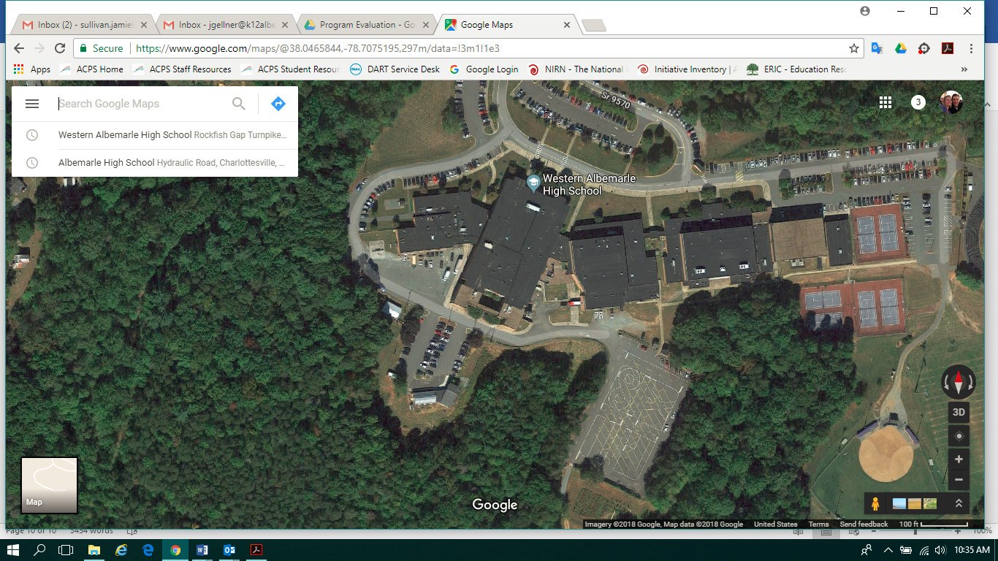

Monticello High School has a designated range space in the front of the school that doubles as the bus lot. A room nearby serves as storage and office space. The range space is 190’ x 280’. It is not marked and the instructors must set up cones each time that it is in use. This is challenging because of the time it takes to do so and because people view it as other things (namely, the bus loop or a parent drop off area) rather than the driving range. Monticello does not have a tower. Driver Education cars are parked there and the teachers and the program lead expressed concerns about the security of them. Signage, additional equipment, and consistent monitoring of the space could assist with the challenges with the set-up of the range space.

Monticello High School range in front parking lot, also bus loop
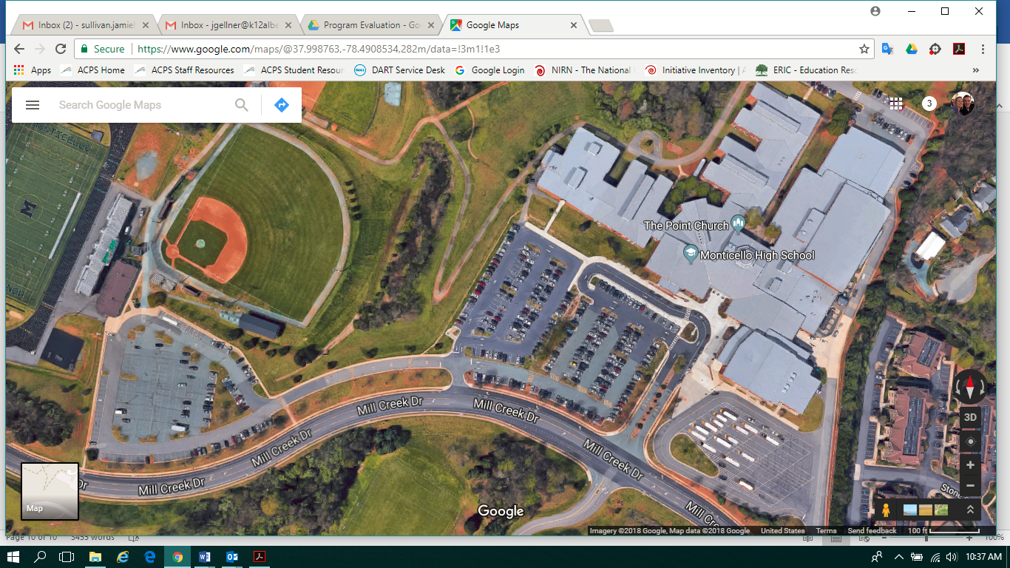

Close up of MOHS range with cones set up and without school buses
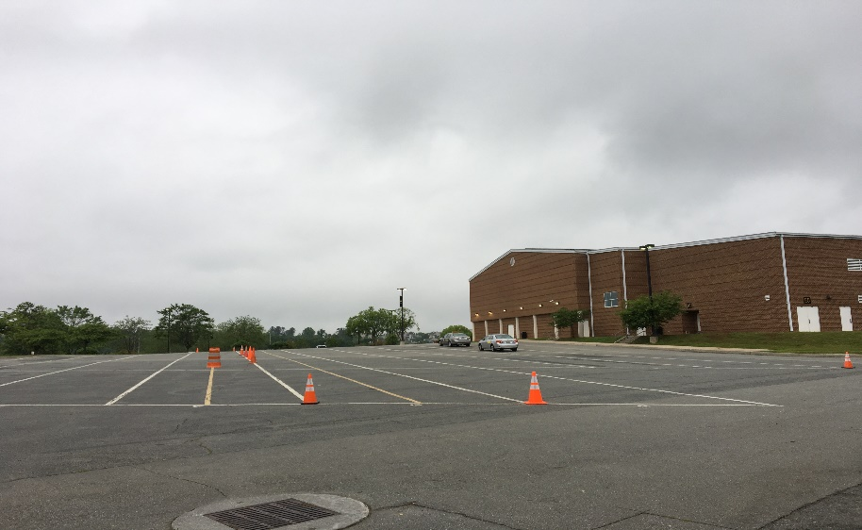

Albemarle High School has the designated space that is the multi-car driving range located near Jouett. It is fenced in and houses 14 Driver Education vehicles. The tower on-site also doubles as the office space for most of the Driver Education staff and as storage. The lower floor of the tower has potential for development of a VR lab to provide simulation training. The layout and current usage of AHS makes it challenging for an alternative range placement. The way that the front parking lot is laid out, the amount of traffic, and the proximity to Building Services and LEAD makes it difficult to repurpose any of the front lot for Driver’s Education instruction. The back parking lot could work as an alternative if it was painted and designated, but probably not in its current state and not without changing its current use and finding alternatives for those activities. The back parking lot is currently designated as the motorcycle safety range and it is also heavily used by AHS students for band practice and other activities. The dimensions of the multi-car range are not available, but the back parking lot is 160’ x 360’.

Albemarle High School Multiple Car Driving Range, located past AHS on Lambs Lane
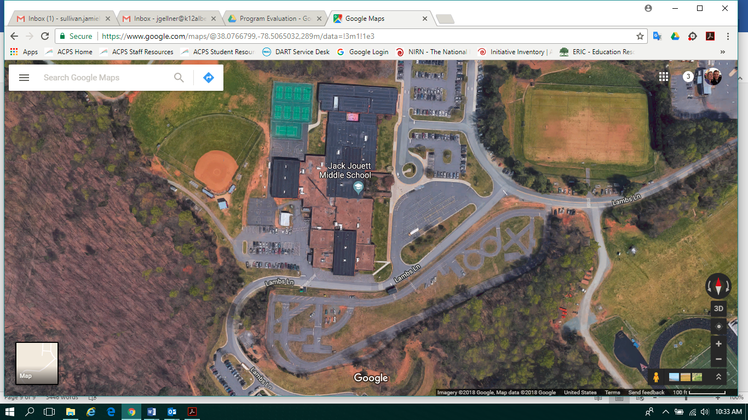

Rear Parking Lot AHS
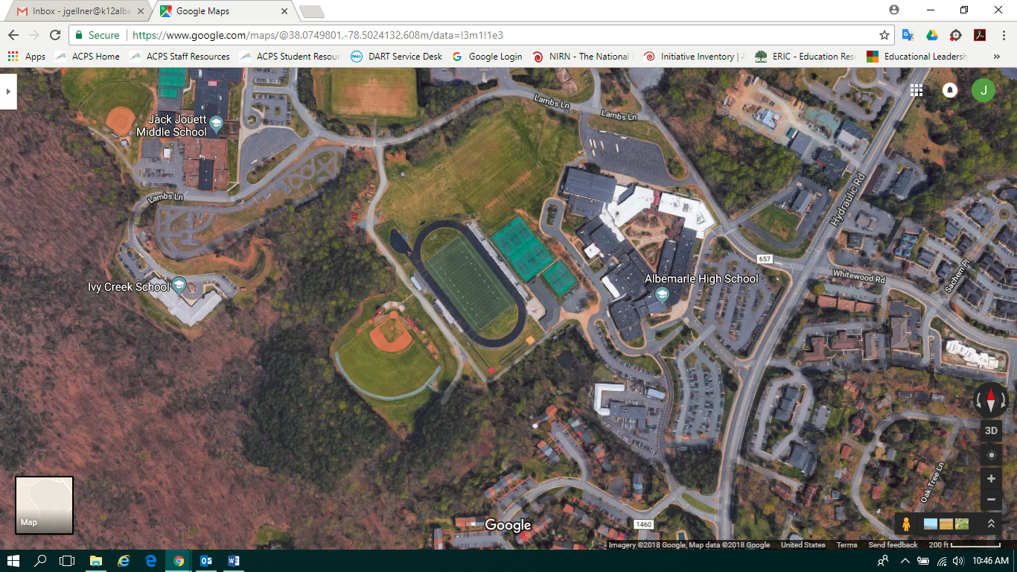

Program, Participation, Outcomes Comparison

Programs
Albemarle | Monticello | Western Albemarle
Secured Multiple car driving range in its own space with range tower, storage, vehicle parking space  Size unknown, but larger than standard (150’ x 300’ or 300’ x 500’)  14 Cars | Parking lot with cones, must be set up for each use; costs more for staff for set up of range (time)  190’ x 280  8 Cars | Multiple car driving range with painted lines (not secured) in back parking lot with range tower and parking spaces  280’ x 200’  8 Cars
9 Teachers: 4 classroom, 3 In Car only, 2 classroom/In Car | 5 Teachers: 1 classroom, 3 classroom/In Car, 1 paraprofessional (In car only) | 6 Teachers: 1 classroom only, 3 classroom/In Car, 2 paraprofessionals (can only teach in car)

Participation In Car/Behind-the-Wheel Instruction During the School Year
Year | Albemarle | Monticello | Western Albemarle
2015-16 | 109 | 130 | 81
Summer 2015 | 31 | 16 | 14

Crash Rate Each School as Reported by VDOE
Year | Albemarle | Monticello | Western Albemarle
2015-16 | 3.59 | 4.35 | 3.23
2014-15 | 5.26 | 3.64 | 2.67
2013-14 | 5.97 | 4.72 | 1.05
2012-13 | 4.9 | 0 | 1.8
2011-12 | 5.86 | 2.31 | 4.35

Staff Interviews

In the month of June 2018, eleven people were interviewed for this program evaluation— six teachers, three who teach the classroom portion and three who teach both classroom and behind-the-wheel; two VDOE staff members who specialize in Driver Education; one instructor in higher education who endorses driver education instructors across the state; and, three other related ACPS staff who work with Ms. Waters-Wicks (one principal, one director, and one office associate).

The interviews were designed to be completed in thirty minutes or less at the request of the program lead in the end-of-year timeframe.

VDOE Staff and Higher Ed Staff Interview Questions
- What are best practices for school divisions who wish to run an outstanding Driver Education Program?
- Who is one of your strongest divisions? Why?
- What makes for a weaker program?
- How does Albemarle compare to other school divisions across the state?
- What trends are you seeing in the Driver Education Program?
Responses
The three interviews from the state and higher education staff reveal that Albemarle County Public Schools is recognized as having a strong Driver Education Program in the state of Virginia. All three spoke to the high quality staff in ACPS schools and the VDOE staff spoke to the “low” crash rates which are “above average.” Besides Albemarle, staff members noted that Newport News has high quality driver education experiences due to its staff and its multiple car range experience. The three staff members also specifically complimented Karen Waters-Wicks on her efforts to maintain a strong program with knowledgeable staff.
In order to promote access to a driver’s license, offering driver education, both the classroom component and the behind-the-wheel component, is a best practice. Having a multiple car range is also a “best practice,” although most school divisions use parking lots to do range work. Vanessa Wigand stated, “Most school divisions run a seven-day program and use parking lots each day to use range work. Everything that you do on a range, you can do that on any parking lot that is not buzzing with kids.” Quality teachers who develop decision-making skills and safe “attitudes” in students is a best practice. Providing as much real driving experience to young drivers is important as well as having the classroom and in-car or behind-the-wheel portions of instruction as close together as possible. Finally, offering the program at an affordable rate to all students is a best practice.
The only trend mentioned is that the Department of Motor Vehicles is developing a pilot to outsource its licensing testing. ACPS could become a testing center for the DMV in the future if there is a need.
Teacher and All Other Staff Interview Questions
- What are the strengths of the Driver Education program?
- Where are opportunities for improvement in the Driver Education program?
- What aspects of the Driver Education program provides advantages or challenges for students/families? Teachers in the program? The community?
Responses
Although the third question allowed those being interviewed to elaborate on their responses, all responses fell into the categories of “strengths” or “opportunities” for the Driver Education program. VDOE staff and program staff view Driver Education as a very strong program. Parents and community members were not polled. Listed below are all of the comments related to strengths and weaknesses, followed by a few direct quotations to highlight the ideas.
Strengths
- Five people spoke about the importance of the multiple car range at Albemarle High School. They highlighted the “authentic, real-world” instruction, the availability of a safe space for both teachers and students, the security of the space for storage and vehicle parking, and that it is “special” because not many schools have it.
- Five people highlighted the experience and expertise of the teaching staff as well as how seriously they [the teachers] take their work.
- Seven people discussed the strength of the VDOE curriculum and that it provides consistency. There is a strong collaboration between VDOE and the ACPS program and the VDOE program is a “model program” that other states follow.
- Three people mentioned that behind-the-wheel is offered before school, during school, after school, on the weekends, and in the summer.
- Four people highlighted the parent seminar as a strength because it engages the parents and it is provided at all three large high schools. Crash rates went down in ACPS after implementing this (says staff).
- Five people complimented Karen Waters-Wicks on her leadership of the program. They highlight her communication, her efforts to provide resources to her staff, her willingness to provide professional development to keep staff current on best practices, and timely communication of legislative updates.
- Three people highlight the convenience of having it at school-the location.
- Two people said that offering the program is good for the community. Private school students are able to take our classes and the program serves the adult population in the community as well. People from other countries or people who grew up in cities or never learned to drive can access the program.
- Albemarle offers diverse driving environments for training.
- Cars are well-maintained by the Vehicle Maintenance Facility.
- Teachers are very accessible to students and parents.
- Two people said that the program allows students and parents to feel connected to the school.
- Three people said that the program was fairly inexpensive for the “value.” They discussed that the cost was equitable to the product that students receive.
- Teachers highlight earning a very useful skill (driving).
- The program has low crash rates.
Opportunities
- Four people said to shorten the modules for the classroom portion.
- Related to this idea, three teachers said to make Driver Education a semester long class and/or an elective and take it out of Health and PE II. Health and PE II must cover Driver Education, Family Life, Mental Health, and other curriculum and they feel it is too much.
- Six people said the cost for the behind-the-wheel portion is too high. One also commented on the private companies that do provide it more cheaply (there is one).
- Teachers would like more behind-the-wheel time for students and to teach additional skills.
- Scheduling is a challenge for students’ busy schedules. People suggested ideas like providing more training time for behind-the-wheel during the school day, if possible. They also liked this idea because there is less traffic than before or after school.
- Four people noted the shortage of in-car teachers and one noted a shortage of classroom teachers.
- Three people noted that the site at Monticello High School is not ideal. It is challenging to set up the space and the training area and vehicles may not be secure.
- One person suggested that the program should be “more structured like a business to get more kids.” The person suggested a small marketing campaign because the “competition doesn’t have what we have[in terms of quality].”
- Two people would like to see more parent involvement.
- Two people suggested providing a range space that all three schools could access and to look at the “Safety Town” model in Chesterfield as an example range.
- One person emphasized that “safety is more important than numbers and dollars” and suggested that there should be a retake fee and parents should have to ride along with the student on the retake.
- Two said there should be efforts to couple classroom and in-car training for students as much as possible.
- One person said they would like smaller class sizes for the classroom portion.
Direct Quotes
“We are always talking about real-life learning opportunities…it’s a real-life classroom.” (in reference to the multiple car driving range)
“The average parent trusts the school and attaches instruction to teachers, so they’ll want to pay the school over the outside agencies.”
“One of the real strengths is that we give young people the opportunity to become skilled with professional training. I think we are very fortunate because so many schools have gone to private and commercial driving schools—students aren’t getting it.”
“Students who have taken classes elsewhere with that they had taken it from you. I am confident in my abilities and what we offer here.”
“A senior citizen evaluation—he was 91—the family sent him. He sent a postcard back and said he was part of the Albemarle family and will be a Patriot forever.”
“The crash rate declined hugely after the parent mandate. We have the 45-hour parent driving guide, but once parents have to sit through and listen to how it is now, they get it better.”
“The cost is a challenge for families—economically disadvantaged kids at our school. They just wait until they turn 18…..other students it’s bigger than that. I have a student who is going to lose her job at a grocery store because she depends on rides and can’t get there on time. Even if she got her license, she doesn’t have a car.”
“Knowing Karen and the program she runs, I know she has it under control and a plan. Keep up the good work.”
“We could figure out how to do the Health and PE II curriculum better [if we had more time to plan]. No doubt that Health II units get short shrift so we have to tweak mental health, family life, to make it all work. Maybe do things [curriculum] differently at each school based on team?”

Student and Parent Survey Results

Because the report did not go to the School Board in August, 2018, staff conducted an additional survey in September in order to validate assumptions about participation and to gain additional feedback about the program. The survey was open from September 5, 2018 – September 21, 2018 and was sent to sophomores, juniors, seniors, and their parents. Response was limited from students at only about a 2% response rate, but parents participated at about a 20% response rate. The results are below.

Student Behind the Wheel Survey

Q1. Which grade are you in?
Responses | Responses | % | Percentage of total respondents
10 | 29 | 42.6%
11 | 24 | 35.3%
12 | 15 | 22.1%
Total Responses | 68

Q2. Did you take the behind-the-wheel portion of Driver Education with Albemarle County Public Schools or did you take it with an outside company, like Greenlight or Albemarle Driving School?
Responses | Responses | % | Percentage of total respondents
Yes, I took it with ACPS at Albemarle, Monticello, or Western Albemarle | 14 | 19.7%
Yes, I took it with an outside company | 15 | 21.1%
No, I have not taken behind-the-wheel | 42 | 59.2%
Total Responses | 71

Q3. What was the primary reason that you chose to take it with either ACPS or an outside company?
Responses | Responses | % | Percentage of total respondents
Location | 7 | 25.9%
Cost | 1 | 3.7%
Schedule (to accommodate my schedule) | 8 | 29.6%
Availability (when the course was available to be taken) | 6 | 22.2%
Other (Please specify) | 5 | 18.5%
Total Responses | 27

Q4. What is the primary reason why you have not taken behind-the-wheel?
Responses | Responses | % | Percentage of total respondents
Have not earned my permit | 18 | 42.9%
Do not have a car | 0 | 0%
Not interested in getting my license or do not need my license | 2 | 4.8%
Do not have car insurance/parent doesn't want me on insurance | 0 | 0%
Cost for behind-the-wheel | 2 | 4.8%
Availability/Scheduling of behind-the-wheel | 5 | 11.9%
Location of behind-the-wheel | 0 | 0%
Plan on doing behind the wheel in the future, before I am 18 | 10 | 23.8%
Plan on getting licensed after I am 18 | 1 | 2.4%
Other (Please specify) | 4 | 9.5%
Total Responses | 42

Students reported limited responses for the open-ended questions. When asked about strengths of the behind-the-wheel portion of the Driver Education program comments suggested the cost, the instructors, the instruction, and the use of the range. A weakness mentioned is the “availability,” for time slots. This could mean more opportunities, meaning the need to hire additional instructors, or it could mean adding more time slots for choice.

Parent Behind the Wheel Survey
Q1. In which grade(s) is your student(s) enrolled?
Responses | Responses | % | Percentage of total respondents
10 | 357 | 44.2%
11 | 262 | 32.4%
12 | 236 | 29.2%
Total Responses | 855
Multiple answers per participant possible. Percentages added may exceed 100 since a participant may select more than one answer for this question.

Q2. Did your student(s) take the behind-the-wheel portion of Driver Education with Albemarle County Public Schools or did he/she take it with an outside company, like Greenlight or Albemarle Driving School?
Responses | Responses | % | Percentage of total respondents
Yes, with ACPS at Albemarle, Monticello, or Western Albemarle | 220 | 27.1%
Yes, with an outside company | 176 | 21.6%
No, my student has not taken behind-the-wheel | 417 | 51.3%
Total Responses | 813

Q3. What was the primary reason that you and your student(s) chose to take it with either ACPS or an outside company?
Responses | Responses | % | Percentage of total respondents
Location | 74 | 18.8%
Cost | 31 | 7.9%
Schedule (to accommodate our schedules) | 150 | 38.2%
Availability (when the course was available to be taken) | 92 | 23.4%
Other (Please specify) | 46 | 11.7%
Total Responses | 393

Q4. What is the primary reason why your student(s) has not taken behind-the-wheel?
Responses | Responses | % | Percentage of total respondents
Has not earned his/her permit | 157 | 38.0%
Does not have a car | 5 | 1.2%
Not interested in getting a license or does not need a license | 15 | 3.6%
Does not have car insurance/parent doesn't want student on insurance | 5 | 1.2%
Cost for behind-the-wheel | 44 | 10.7%
Availability/Scheduling of behind-the-wheel | 21 | 5.1%
Location of behind-the-wheel | 0 | 0%
Plan on doing behind the wheel in the future, before age 18 | 99 | 24.0%
Plans on getting licensed after age 18 | 10 | 2.4%
Other (Please specify) | 57 | 13.8%
Total Responses | 413

In question 3, many of the “other” comments should have been “schedule” or “availability.” Many parents indicate that they took the behind-the-wheel course with ACPS or with a private company simply because it fit their student’s schedule better. Other reasons for taking it with Albemarle were quality of instruction, instructors, and taking the class with classmates. Other reasons for taking with a private company included they didn’t know it [ACPS] was available to them, they couldn’t find or didn’t have information about the program, and that students can be picked up and dropped off at home.

In question 4, many of the “other” comments should be added to “has not earned his/her permit,” “availability/scheduling,” “cost,” or “plan on doing it in the future.” There were a few other singular comments that stood out as slightly different. They are “lack of information on program,” student is “not mature enough,” “not old enough,” “afraid,” “special needs prohibits right now,” “working on 45 hours of practice,” “too lazy to get permit,” and “didn’t take the prerequisite course yet.” Some of these responses indicate that our students are mirroring national trends in waiting to earn a permit whether they are “not interested,” or “lazy,” or “not mature enough.” For others, it seems that schedules are busy and it is hard to fit it in all of the GDL requirements.

There were two open-ended questions at the end for parents who had participated in the ACPS program. The first asked about the strengths of the program and the second asked where the program can improve. The complete list of comments can be accessed at the end of this report.

Parents indicated most often that the instructors are experienced and knowledgeable, instruction is high quality, the program is convenient (location and scheduling), and many said the cost was affordable. Many others also indicated that it is a good program because it is a school program—indicating that they trusted the curriculum, placed “trust” in the teachers, and in the schools to do a good job and keep students safe.

Parents indicated most often that the program could be improved by offering more time slots, particularly during the school day or on the weekends; offering more instruction or more training time, particularly with parallel parking and busy highways; and improving the cost of the program by reducing the cost or offering scholarships for some. Other suggestions included providing more information to parents online and improving communication with parents, improving registration and payment online, hiring more instructors, potentially making behind-the-wheel concurrent with classroom driver education, making the program more consistent across high schools, provide newer vehicles, offer earlier classroom courses for freshman who are already 15 1/2 , place cameras in the cars, and offer a 1:1 program.

Conclusions and Recommendations

Overall, the Driver Education program in Albemarle County Public Schools is strong. Teachers and staff made several good recommendations for potential program changes and Ms. Waters-Wicks can review opportunities with her staff. Based on survey comments, there may be areas for improved communication. During the course of the evaluation, potential for data collection processes to be digitized were realized so that we can investigate questions about participation more fully.

The evaluation does suggest that the ACPS Driver Education program is fulfilling an otherwise unmet need for the community. Without driver training in schools, there would be limited opportunity to earn a driver’s license in the area without a huge increase in commercial schools. Another purpose of this program evaluation was to examine the participation data of the Driver Education program to see if there is an opportunity gap. While our program does exhibit similar trends as the nation, in terms of the numbers of black, Hispanic, and economically disadvantaged students completing the behind-the-wheel course, ACPS also sees similar trends of an overall lack of participation in the program by eligible teens. In the follow up survey, many indicated that they did not earn their permit, which is a step that students must motivate to take on their own. Instructors with many years of experience talking to students say that it is because of decreased interest in obtaining a driver’s license and because of economic reasons not related to taking the class (i.e. not having a car, not able to afford insurance). This is problematic for our community as a whole because when these drivers do earn a license, they will not have the same experience afforded under the GDL laws. Additionally, youth who do not have driver’s licenses will have fewer opportunities after graduation in terms of accessing future jobs or continued schooling.

The participation data for the classroom portion of Driver Education shows a lower participation rate for white and Asian students, presumably, because they are taking it online. Students who can afford to pay for online courses in the summer are able to take other courses during the year. This is one indicator of the “opportunity gap” for low-income students (i.e. that low-income students have difficulty ascending into a higher income status). In this scenario, higher income students are able to take some classes online, freeing up spots in the regular high school schedule to take additional courses. For low-income students, ACPS sees high participation in the classroom portion of driver education and lower numbers in the behind-the-wheel portion.

Ms. Waters-Wicks has spent considerable time lobbying for scholarships for her students and has earned a few through State Farm. She also instituted a pay-by-installment plan that has helped some families. In ACPS history, there has been a contribution for students who are economically disadvantaged, or identified in the free and reduced price lunch program. The Board could reduce or eliminate fees for these students, so that even if larger financial challenges prohibit them from driving, they will earn a quality and usable skill through the school system.

There may be an opportunity to increase the motivation to obtain a license with the increased focus on CTE courses and real-world skills in education. One of the 16 career pathways is the Transportation, Distribution, and Logistics cluster. Jobs in this cluster will increase by 7% over the next decade in Virginia and currently there are many shortages. Other factors like the potential for the DMV to use schools as testing centers for drivers over the age of 18 and perpetual shortages of school bus drivers could provide additional opportunity for the Driver Education program to innovate and make even stronger connections with the community by partnering with the DMV and even considering partnering with Transportation Services for CDL training. There are some states that have had success with 18-year-old school bus drivers and obtaining a CDL is a valuable skill for future job earning potential.

References

Christie, R. (2001). The effectiveness of driver training as a road safety measure: a review
of the literature. Victoria, Australia: Royal Automobile Club of Victoria.

Farmer, C.M. and Wells, J.K. (2015). Crash and citation records of young drivers with skid
avoidance training. Arlington, VA: Insurance Institute for Highway Safety

Mayhew, D.R.; Simpson, H.M.; Williams, A.F.; and Ferguson, S.A. (1998). Effectiveness
and role of driver education and training in a graduated licensing system. Journal of Public Health Policy 19(1):51-67.

Shults, R.A.,& Williams, A.F. (2013). Trends in driver licensing status and driving
among high school seniors in the United States, 1996-2010. Journal of Safety Research.

Subramanian, R. (2012). Motor vehicle traffic crashes as a leading cause of death in the
United States, 2008 and 2009. Report no. DOT HS 811620. Washington, D.C. United States Department of Transportation.

Tefft, B.C., Williams, A.F., & Grabowski, J.G. (2013). Timing of driver’s license
acquisition and reasons for delay among young people in the United States, 2012. AAA Foundation for Traffic Safety.

Thomas, F.D.; Rilea, S.L.; Blomberg, R.D.; Peck, R.C.; and Korbelak, K.T. (2016).
Evaluation of the safety benefits of the risk awareness and perception training program for novice teen drivers. Report no. DOT HS-812-235. Washington, DC: National Highway Traffic Safety Administration.

Valeii, K. (January 16, 2018). Driver’s ed is becoming harder for poor kids to afford.
Pacific Standard. www.psmag.com.

Vernick, J.S.; Guohua, L.; Ogaitis, S.; Mackenzie, E.J.; Baker, S.P.; and Gielen, A.C.
(1999). Effects of high school driver education on motor vehicle crashes, violations, and licensure. American Journal of Preventive Medicine 16(Supple 1):40-6.

Virginia Department of Education in cooperation with the Virginia Department of Motor Vehicles. (2017).
Curriculum and administration guide for driver education in Virginia 2017. www.doe.virginia.gov.

Williams, A.F. (1994). The contribution of education and public information to reducing
alcohol-impaired driving. Alcohol, Drugs, and Driving 10(3-4):197-202.

Williams, A.F. and Ferguson, S.A. (2004). Driver education renaissance? Injury
Prevention 10(1):4-7.

Williams, A.F. (2011). Teenagers’ licensing decisions and their view of licensing
policies: a national survey. Traffic Injury Prevention, 12, 312-319.

Zhu, M., Cummings, P., Chu, H., Coben, J., & Li, G. (2013). Graduated licensing and
motor vehicle crashes involving teenage drivers: an age-stratified meta-analysis. Injury Prevention, 19, 49-57.

Complete Survey Comments for Parent Survey
Q5. What are the strengths of the driver education program?
My driver learned a lot through the program and came out of it as a prepared driver. I think the program is strong.
We appreciated having ACPS offer this course at the school. It worked well for us and we felt the course achieved the desired result of creating a safe student driver.
Location
Instructors are very real. Both of them taught my son how to handle a car on the road without loosing their tempers as parents are prone to do b/c it is scary teaching a teenage boy to drive.
It's a requirement to get the license, so having it at school helps with costs for parents.
close by, reasonable cost, availability
The school has an overview of the whole process, not just one piece (like behind the wheel or the permitting process). I trust that the program is comprehensive.
Teachers very positive, cover a lot of road safety, get students to try, retry until they get it right. Always focusing on safety first!
Students can walk from AHS after school
Convenience! Having my sons stay after school and get their Behind-the-wheel education was extremely convenient for us. The cost was also a fraction of what private drivers ed outfits charge.
My child felt comfortable with the teacher and learned important information about safe driving.
I believe the course covered the basics.
2:1 ratio of students to teacher.
I feel that having our student drive with other qualified adults during the learning process helped to strengthen their skills as a driver.
It was flexible to our schedule and allowed us to do weekend.
I have no problem with the problem
In-School program
WAHS staff has the reputation of providing a rigorous course.
It provides the summer session and allows students to retake the test free. However, it's hard to schedule a re-take because the lady in charge is rather busy and too strict for the test. For example, she picks on students to go only 5 miles over the speed limit.
I didn't have to be the passenger initially! Very convenient.
Location and excellent staff
My daughter learned a lot from this class.
Convenient
Currently enrolled but she already has her learners permit.
Personal interaction with the student in real life situations.
qualified and experienced instructors, opportunity to observe another student driver as well as drive
Location and cost. It makes scheduling easier too, which is important for a busy high schooler.
When it is offered (right after school) made it easier for us to navigate.
Unknown to me
offered at school with the regular curriculum
Ease of access. Location. Cost.
Fantastic teachers at Monticello High School
I don't know that much about the driver education program at ACPS.
Very well organized. Felt better about it being part of the school system.
It’s super convenient that sophomores can take it during their health block - works right into the kids’ class schedules!
The before school behind the wheel training is very convenient for students and families.
one on one training with a good instructor
It is tremendously convenient to have it as part of the school day. You don't have to invest additional time to schedule and plan for the course and no add'l drop offs or pick ups. There is no additional fee that you would incur by going to an outside school. We are grateful for the opportunity!
It is ideal having the driver's ed program located at school, and classes can be worked around students' schedules. Also, the road test is taken at school and given by the same teachers. I have had 4 children complete this course at MHS, and Driver's Ed teachers at Monticello are excellent!
Great instructors.
Professional instructor. Great scheduling. Reasonable cost.
My son just started taking the class
Btw
Good location, good instructors, good cost
Convenience of location and convenient times.
Number of hours and various locations.
They cover a lot
Much prefer to do in-school. Kids are so busy that it is really hard to find time to do it outside of school.
Very convenient, friendly instructors
its convenience in terms of scheduling and location.
Teacher, ms. Neuhauser was so patient and very detailed in her feedback
My daughter took the summer classroom option because the fall classroom option conflict d with her courses.
Good value for the money. Convenience of having the program located at the high school. Reasonable and accessible Behind the Wheel student schedule.
Two children completed program with no problems. Seemed easy to access through school system, and priced affordably. Great experience.
Easy to intergrated with schedule and school.
We were quite happy with the program. Very flexible and emphasis on safe driving.
Standardization
Excellent program. My kid learned so much from the course. The teachers were awesome.
Convenient and efficient in terms of supplementing parent teaching.
In the past, 2 of my students reported instructors who yelled and created anxiety. My most recent student had a relatively calm instructor who treated her with respect. I have not looked at other programs but ACPS seems to provide many time slots for instruction
My student learned a good deal of info even after having driven with his permit and logged many hours. Good tips that he passed onto his parents. Nice that he knew the instructors from school, convenient to do before school. Nice giving seniority to older students for scheduling.
teachers know the kids kids feel comfortable with the teachers teachers know how to approach the student with driving improvements/encouragement
Thorough educ
It gives students a chance to get practice hours in with a neutral third party that is trained in driver education and will emphasize things that a parent might not, or reinforce similar themes that drivers have heard from their parents.
no idea
The relationships piece is a big one. Students see Ms. Wicks and in our case, Mr. Hendricks in their school building throughout the school year. Having that familiar face and established relationship helps ease the nerves for what is a particularly anxious task-passing behind the wheel.
Robust and positive learning environment.
Could find times that worked for us and it was based out of the school.
Instructors are great.
In the local school during school hours is very helpful! Great teachers!
Close to High school
Current expertise
Location, cost
Having the driving course at AHS is a plus. Knowledgeable, friendly instructors.
Run through the school system, right after school, so very convenient.
I thought my son learned a great deal at the BHW program. The instructor told them in the beginning what to expect and seemed very calm with the students from what my son said.
Hands on driving instruction from experienced personnel, hopefully aligned with Drivers Ed classroom curriculum.
My daughter’s Driver Education teacher (Ms. Sherill) and Behind-the-Wheel teacher (Mr. House) were both great instructors. They clearly knew their stuff! They also felt comfortable working with high schoolers.
Teaching them to drive with peers and under a planned curriculum.
Teaching the students proper driving etiquette.
Great training, easy location and scheduling for students who can't drive, low cost, can do with peers for peer support and additional learning.
Experienced, knowledgeable instructors, and the ability for student to take road test through the program.
great teacher
It is very convenient to do it before or after school.
The convenience of the course and the quality of the instruction.
Easy to work bnb into schedule, local suppirt. C ou st
Start them out slowly, take them to learn areas that are tricky.
I thought it was a great program- instruction very good
The fact that they take it during school hours. That they are on site. That is is a course and is very cost effective.
The scheduling, a non-family member supplementing the education the student receives from parents.
Wonderful instructor, reasonable cost, accessible, high quality
The students are exposed to many different driving activities. Our area can be complicated to drive in due to the many different types of roads (rural up to interstate).
Can do with peers right at school, good teachers
Good teachers, are enrolled with peers from school
The supervisor of the program cares about quality and about the student drivers/families.
From what I have seen and heard it is an in depth course.
The parent meeting is great, having garbage cars, the driving course at the high school. Different options for drivers ed.
certified program. It is done through the school system. We trust the school program more than we trust a random private company. It is done at the school. We have easy and correct information about our students driving ability.
We appreciate that this program is offered through her school and she can meet all her requirements at the school.
locality, excellent driver training course at Jouett, rigorous requirements
My son took it at Monticello, where he attends as a student, and it was convenient for him to do it before school each day.
Great program to allow students to get comfortable behind the wheel in a safe environment that compliments the parents' work to train the new driver.
The hands-on driving portion was excellent. I like the idea of having a professional teach my child as he/she is updated on any new rules of driving.
Classroom program is part of Health II. Outstanding Driver's Ed teachers (Mr. McDaniel) Competitive cost
flexible scheduling around school and sports. cost is more reasonable through ACPS than outside company. Instructor was well trained and felt they had something to offer my child beyond what we provided as parents in driving instruction
He is currently taking the class.
It is included in the school day
I don't know.
not yet taken
Good program overall, but timing doesn’t work for all birthdays. My 12th grader did well with the school’s program. I also have a 9th grader. For him we may schedule with a private company so he can get through it sooner. He will be eligible for his learners permit at the end of 9th grade.
It built his driving confidence
I can't say enough good things about the behind-the-wheel program at Monticello HS. The instructors were very accommodating, plus my son learned a lot and had a great experience. My daughters went through a commercial driver's training program in AZ which was more expensive and not as comprehensive.
My daughter took the class in the summer. Lots of times and dates to choose from. Liked the compact 1 week schedule. Liked rotating instructors to get different perspectives.
I thought the instructor was very good. I hope AHS keeps the location and it is not torn down for the Boys and Girls club, it is very convenient for working parents since it is incorporated into the school day.
the driver ed course at AHS is an excellent resource for student drivers to learn; The summer schedule of available courses fit our schedule; cost was reasonable
0
Not taken yet enrolled for end of oct
Instructor had some great tips and child was more likely to listen to the instructor over the parent.
Discussion with the teacher and classmates
Brand new to it, so I don't know yet but I appreciate it being available rather than having to go elsewhere and pay for it both in money and in time.
I like the fact that it is available through the high school which makes it easier to fit my schedule.
Seemed complete. Practice was on different roads/situations. I like the parent seminar. I learned some things.
quality
My son took the class first semester and was more than ready for the test in December. He enjoyed the class
They've been doing it for years.
The instructor exceeded expectations. The instructor’s performance exceeded by a considerable amount the very costly private instruction obtain for another child.
Fantastic teaching. I learned how to be a better driver though my student. Very safe. Hours are very reasonable.
Good fundamentals of the class.
Scheduling it at the school is very helpful. I would say the answer to the primary Reason question (above) should be "All of the above". I also like that the kids got instruction on how to drive on their own roads.
To give student more awareness from the state o driving
The instructors taught my daughter a lot. She found the class to be very informative.
It was easy to attend- location was good for us @ MHS
we were able to do the driving test within the program and not have to go to the DMV
Conveinient
convenience
I was very impressed with the driver's education program at AHS. I felt my daughter received way more training and practice than I did when I was her age. I feel like this is so important considering how serious and potentially dangerous be driving a car can be.
Experienced teachers; flexible time offering; short seven-day courses
Good teachers
Real time behind the wheel. Honest feedback from the instructor. Not having to schedule an appointment with the DMV. Convenient times before and after school and summer program.
close to home, at school, familiar teacher
Instructor was detailed , thorough and demanding in a good way!
Cost, location, time is all convenient for my student to attend right after school.
On sight during school hours
Being able to take the drivers test with someone they were familiar with instead of a random stranger at the DMV.
Convenience to our home, value and quality of instruction
Bella really enjoyed her experience with Tom Legard
It is a nice service to have
It was wonderful from start to finish. If a session was missed due to weather, the instructors came in on weekends.
Having driver's ed available through the school was extremely convenient for our schedules, especially living where we do - having to make separate trips to a third-party program would have consumed a lot of time.
Opportunity for objective instruction. Driving with a parent/caregiver isn’t always the best for both. Objectivity really supports successful learning.
The teachers ability to connect with our student. Teaching the importance of safe driving practices. The best Insurance isn't on a piece of paper, It's knowing that your skills and vehicle are up to meeting and handling any obsticles that present themselves when your on the Highway.
Gives students opportunity to drive in different traffic conditions.
Location and availability
Great teaching in a comfortable environment (her own school) at a competitive price. The teacher seemed very experienced and knowledgable and was very flexible and available for scheduling.
N/A
Quality instruction
Location, cost are both great compared to private companies.
Honestly, we didn’t over-think this since it was part of the curriculum. He took it in the summer so as not to conflict with his academic schedule.
instructor with years of experience. Ease of access
Convenient location and summer lessons
Convenient, cost, availability
Program was not a strength... Had to drive to Monticello -40 minutes away for the my daughters to take the program on Sat. because their original driver was no longer available. Then we we didn't even finish until late summer.
Comprehensive, honest and my son and daughter both felt comfortable with their instructors.
Training in a classroom environment before going on the road
Accountability of the student to complete the program, the teachers know the students and how they learn.
basic introductions to laws, signs, and driving.
Scheduling; quality of instruction
Being so close to school, having the practice track.
Offered through school
Focused training and appropriate corrections. Holds students responsible

Q6. What are some opportunities for improvement in the driver education program?
Increase availability
I was pleased with my sons experience.
Why have this AFTER the kids have learned bad habits? Should be mandatory during the classroom portion as a first step to learning to drive.
somewhere on the school website, it would be helpful to have an overview of the process. Something like 1. sign up to take driver ed through health class during your sophomore year, 2. get your permit at age 15.5, 3. etc.
Having students be able to drive longer or assist more with students merging in/out of traffic on busy highways & interstates
More instructors with more available time slots. Easier more convenient was to register for classes.
Offering weekend options would have been nice as well. Before and after-school activities made it hard to find a time of the year when they would be consistently free for a couple weeks. For that reason, we delayed getting it done until sports were on hyatus.
None that I can think of
I would have liked to have seen more time on the 118 64 /250 exit. This is a dangerous location. I do not feel that the basic program really prepares new drivers for dangerous situations they may encounter. Skidding, off road recovery, animal running out in front.
The cost is prohibitive. When registering, I didn't see anything about financial aid. It was hard for us to pay $325 all at once, but there was no other option if we wanted our son to be able to drive to school. We live in Fluvanna and pay for him to attend MESA. Your program was the only choice.
I would like to continue this program. I thought it was immensely helpful. As far as the statistics, for some reason this generation is uninterested in driving and independence. No fault of the driver education program.
I have none
Communication with parents
The "behind the wheel" program actually expected students to be fully ready for driving before signing up the program, which is funny because then what left for them to teach the students? Some students became intimidated by the coaches because they appear to be less confident than other kids.
can't think of anything
None at MHS
The cost is too high for families in need. Getting grant money or offering scholarships to those who qualify would probably improve the number of students that complete the program.
This program causes stress as there are quizzes / take home work vs more content just covered in class.
Better communication with the Parents. It was not evident to me the process and availability of the program until I starting making phone calls and started to ask questions.
more hours behind the wheel in this program so that there would be a more even balance between parent supervised driving hours and driver ed hours.
Both of my children took it at WAHS and we were pleased with it.
Finding information on when it was offered and getting signed up seemed a bit difficult (probably because info isn't readily available to parents so I had to rely on my daughter!)
Less expensive
the program does not seem to be taught the same at all schools or areas of VA and the curriculum is the same
Extend length of time or offer refresher courses for those students who complete drivers ed before they are eligible to take their driving test.
Better communication with parents
The key to a quality driver education program is to provide families with options for taking this course. The course should be offered during school, after school, and on weekends. This will accommodate busy family schedules and foster independence among our younger drivers.
Can't think of anything currently.
Not that I’m aware of - my daughter is a good driver and is finishing up the driving lessons now
It has worked well for our two children and now a third taking the course.
Class availability is the only issue we have had.
Maybe have it be a little more flexible, so that if a student needs more time than average, they get it.
None suggested.
He hasn't finished the class
More availability
We thought it was very good
I had thought that the program would have done more driving on the interstate and in more challenging conditions.
My daughter just completed a defensive driving class. In this class I realize that she was not taught how she should be scanning the road while driving.
One on one, not 2:1
Not aware of any right now.
Less expensive if needing summer class or more end of the year options
None, it was great!
The summer program was tedious and long, with a lot time wasted due to minimum required hours. Could have covered material effectively in less time. Also, it was only offered during a limited weeks. Improvement should be made to the online option.
Keep up the good work. Maybe offer a few more time slots during the high demand time periods.
again, no problems, seemed easy and efficient.
None
More behind the wheel time
None, it is fine as is. The decline may be due to the increased cost of operating an automobile and/or less motivation or interest in driving by teenagers. I know of two recent high school graduates that are content with their parents driving them. they have not decided on college or jobs either.
I'm not sure what the instructors are teaching since students have to know how to drive before they start. It seems the program is just an extended DMV road test. I suppose this is not in the control of ACPS but more of a DMV requirement. It would be great if it were cheaper
None
Availability of additional scholarships for lower income students.
can't comment
I have no suggestions. The entire process from registration to completion was flawless.
Can't think of any - we were pleased with the program
Someone rarely answers the phone to accept registrations for BTW and also never returns messages. I know people who went to an outside company because they couldn’t get a response. Also, they failed to forward my registration paperwork to the school before BTW began.
More updated vehicles and more time slots to choose from.
Schedule options
Summer
Could help emphasize the graduated licensing aspects of driving and that the actual driving age is 19 and that their parents have some control over their driving privileges. Maybe emphasizing the passenger restrictions as well to help them gain experience before attempting to transport others.
The behind the wheel course should be included into the school curriculum instead of having families pay $300+.
My son's comment was that she was very strict about checking the entire car before getting in. My request as a parent would be to get a couple old cars in the driving practice area and practice parallel parking between actual cars. I don't feel kids learn much by parking between 2 orange cones.
Communication from school re: driver's ed program and curriculum was not clear.
My daughter didn’t like the Driver Education Book. She said some things that were important were not emphasized in the book, and some things that weren’t important were emphasized in the book. She said that her teacher explained everything well.
Being able to take it during fall sophomore year when our kids turned 16 was a bit late for them in their opinion. Ideally, spring of freshman year when 15 1/2 but was not an option. Taking it during the summer was too costly.
Offer more frequently. Practice driving more in University area and down town with numerous distractions and people crossing street, bikes, runners, congestion, etc. This is a good final step for young drivers.
None that I know of, the program was fine.
I feel that the cost is prohibitive to a lot of kids.
I have no recommendations. Both of our daughters benefitted from the program and we were very pleased.
Na
Longer training periods
I personally do not feel like my child was ready to gat her license. I think that the permit was give to her to easily.
Better education with the parents on what is expected from them. Providing resources for parents on teaching their child how to drive.
None
Our child had a very demoralizing experience with the program. The teacher frequently told him he was not putting in effort, he was wasting his parents’ money, he was sloppy, “You have already failed the test 6 times”and “At this rate, you’ll never be passing.” Our son’s confidence was very shaken
Hard to get info
A little hard for parents to get info
Driver instructors should be screened more carefully. Our child had a really bad experience because the instructor used demoralizing language and really damaged his driving confidence. The instructor seemed to use shame to “motivate” students. Recommend installing car cams to monitor instructors.
unsure. My student has not yet completed the course
Even more flexibility and more drivers ed/behibd the wheel openings with scheduling. I have an athlete and marching band guild and it was really hard to find s two week period to do behind the wheel.
We really like everything about it
it would be nice to reduce the cost of behind the wheel.
more accessible times for scheduling (weekends would be helpful like saturday mornings)
I am not sure why AHS needs an on-site behind the wheel driving course. None of the other public schools offer this, nor seem to need it.
I'd emphasize building more confidence in highway driving skills, like merging and passing.
None
Weekend hours for student drivers; given schedule demands and after school activities, getting driving time done during the school day is difficult.
really can't think of any. They were easy to work with and offered several time options for the program
?
My son is currently enjoying this class at MHS
When I was in high school, the driving portion was during school hours.
Figuring out when to schedule behind the wheel was tough. It would be good to be able to do during a study hall.
Frequentcy of classes
Don't change a thing!
More before/after school offerings would be helpful or during free periods. Hard to fit in with sports obligations during the school year. Recommend explaining push-pull steering clearly during the classroom part so they can practice it before getting to BTW.
There was some confusion in our family about the rules for the checking the blind spot when driving.
to NOT get rid of the driver course at AHS; we were very happy with the course
Cost prohibitive. Schedule difficulty. Few slots. Little knowledge gained from behind wheel.. We taught are son to drive. You made it a scheduling nightmare and charged $300.00.. Felt like we were scammed..
Not sure yet
None
My son has only been in the program for a few weeks so I am not ready yet to make suggestions.
none. So far, I have no complaints about the program.
Administration. Coordinate better with teachers as far as dates/times/students. Take credit cards online! Have them send a confirmation after they receive payment!
ok as is
None
Teach about some of the safety features pretty much every new car built will have in the future. AEB, LDW, etc.
The ACPS course is rumored to have a significantly higher failure rate than those of the private providers. Our own experience was not positive as our child was automatically failed for not strictly observing a yellow recommended speed sign while going along a curvy road. Judgment seems arbitrary.
Cost is rather high for a class. Why is this not covered by the county?
Not sure. Seems good.
Possibly allow parents be notified and engaged in what they are learning.
Their should be some type of financial assistance for children below the poverty level.
more cars so it is a one to one driver to car - no doubling up 2 students to one vehicle
I hope they do not take anything away from this program. Relationships between adolescents and their parents can be rocky, and this program provides a very important purpose. Having a teacher , discussing safety and going out with them on the road makes that message resonate more with the kids.
Get info to parents in a mailing
More time practicing parallel parking and 3 point turns
offer some weekend possibilities
Don't get rid of the driving course at AHS.
Very hard to figure out HOW to register and pay. With both occasions , I had to do an in depth website search. Directions are not clear. Unable to pay online.
Online registration
Wish all testing and licensing could be done insight.
I think it was great and good to have for the students
None
We have no complaints!
The windows for completeing behindbthe wheel hours coincide far too much with end of year school responsibilities. The stress for students is really elevated
The Smith System Safe Driving Techniqics Program. It is the best principles for Safe Driving. Also teaching the students an overall awareness and responsibility for having a drivers license and proper monthly maintence to having a safe operating vehicle
Not sure!
Really need to consider the stretches of 29 that kids will be tested on. One stretch we don't even do because of the inability to see cars. Luckily our child approached the teacher and expressed concern. The teacher shifting the route but I fear that some kids don't speak up.
It would be great to offer/require refresher or recap course in the early time period after obtaining a license
N/A
It is difficult for students in sports or band after school to make available behind the wheel times. Before school time is so many days for parents to get students there.
We were happy. We just find it challenging as parents to find the time to drive with him as consistently as we should. But we are doing it over time. We want him to be a safe and confident driver, and that is also his goal.
no issue
The BTW program at AHS is too strict that it expects students to be perfect before participating in the program and the test focuses on the trivial things like hand gesture, turning head, etc. As a result, my teenager failed the test the second time even after she drove a lot during our summer trip.
Unsure?
More drivers
Make sure students are able to parallel park.
Would like to add more time
could use more practical experience -
Unknown
Reduce the cost!
Bring back simulators. More hours behind the wheel

